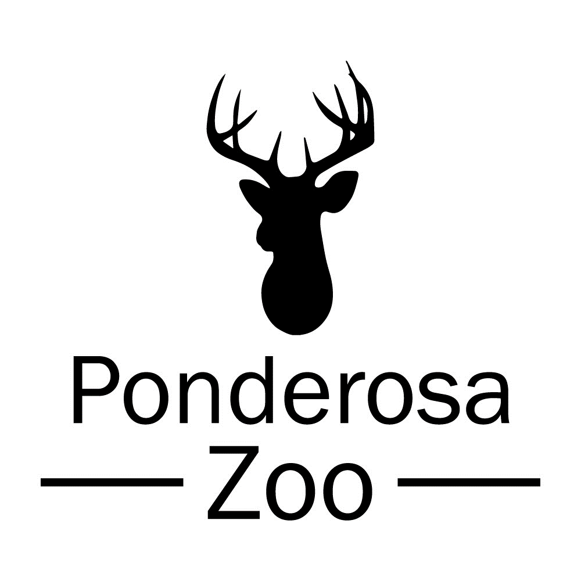
Conservation Policy

Ponderosa Zoo is committed to the conservation of our planet’s natural resources including, but not limited to, animals, plants, and water. In recent years, Ponderosa Zoo has taken various steps to promote effective conservation and sustainability.

In 2021, Ponderosa Zoo became full BIAZA (British & Irish Association of Zoos & Aquariums) members. BIAZA represents only the best zoos and aquariums where standards of animal welfare, education, and conservation are of industry-leading standards.

We currently house a breeding group of Guianan Squirrel Monkeys. These animals are part of the EAZA (European Association of Zoos & Aquaria) Ex-situ Programme (EEPs), which aims to identify at-risk species and ensure a healthy population in captivity to prevent potential extinction. We also house two Scottish wildcats which can be called upon for the breeding programme in Scotland at any point.

Ponderosa Zoo and its employees are passionate about the conservation of both native and exotic species. We have various on-site areas which aim to promote the natural habitats and ecosystems of our native species for example, we have several ‘bug hotels’ and ‘hedgehog houses’ in our conservation area. These sites are monitored regularly to ensure they are suitable for the range of animals we wish to attract and help thrive.

We are enthusiastic in our role of providing education to our visitors in terms of conservation. We offer educational visits for children, during which a keeper delivers a short presentation on a curriculum-relevant subject, before taking the class on a small, guided tour around specific areas within the zoo.

The zookeepers undertake short talks daily at various animal enclosures, during which they discuss the conservation status of the species, and threats they may face in the wild. Our ending message always refers to specific charities or organisations that help to protect the animal in question, and how our visitors can support these causes.

In 2023, we created a partnership with WildTrack, an organisation, who’s mission to protect endangered species uses a combination of artificial intelligence, data analysis, and ecological knowledge. They are currently using FIT (Footprint Identification Technology) to create a database used to identify different species and individual traits. Ponderosa Zoo supports the non-invasive work WildTrack are doing and are helping to build their database by submitting images of our Porcupine, Scottish Wildcat, Serval, and Raccoon Dog footprints.

